**[Your project/thesis title]**

**[Student name]**

**Student Id: [xxxxxxxxx]**

**[Student name]**

**Student Id: [xxxxxxxxx]**

**[Student name]**

**Student Id: [xxxxxxxxx]**

**[Student name]**

**Student Id: [xxxxxxxxx]**

A capstone project in the Department of Electrical and Electronic Engineering presented

in partial fulfillment of the requirements for the Degree of

Bachelor of Science in Electrical and Electronic Engineering



United International University

Dhaka, Bangladesh

[Month, Year]

**Declaration**

We, [Student Names], declare that this project titled [Project Title] and the work presented in it are our own. We confirm that:

* This work was done wholly or mainly while in candidature for a BSc degree at United International University.
* Where any part of this project has previously been submitted for a degree or any other qualification at United International University or any other institution, this has been clearly stated.
* Where we have consulted the published work of others, this is always clearly attributed.
* Where we have quoted from the work of others, the source is always given. With the exception of such quotations, this project is entirely our own work.
* We have acknowledged all main sources of help.
* Where the project is based on work done by ourselves, we have made it clear exactly what was done by others and what we have contributed by ourselves.

________________________________________

[Name, Student ID and Department of the student]

________________________________________

[Name, Student ID and Department of the student]

________________________________________

[Name, Student ID and Department of the student]

________________________________________

[Name, Student ID and Department of the student]

**Certificate**

I do hereby declare that the works embodied in this project entitled “[**Project Title]**” is the outcome of an original work carried out by [Student Name(s)] under my supervision.

I further certify that this report meets the requirements and the standard for the degree of BSc in Electrical and Electronic Engineering.

________________________________________

[Name and designation of Supervisor]

Abstract

<Delete all these contents. Your abstract should go here.>All the pages have been formatted in the accepted font and margin alignment. This is a simple undergraduate project (to be completed in United International University) template that can be used for directly typing in your content. However, if you paste your text into the document, do so with caution as pasting could produce varying results. **When copy-pasting from another document, go to Paste -> Paste Special -> Unformatted Text**. This will not change the setting of this template. When directly typing into the title page and signature page, the appropriate information should be filled in the required fonts.

Acknowledgement

<Delete all these contents. Your acknowledgement should go here.>Its customary and good manners to say thank you however, where do you draw the line? In some of the theses that I’ve read, and I write this after having read thousands, literally, the following and more have been acknowledged: Allah/God, one’s advisor, one’s better half, parents, children, friends, classmates, lab-mates, lab technicians, lab assistants, pets, fav. Prof, neighbors, physicians, exercise trainer(s), wiki, the maintenance guy, landlord, the school cricket team, secretary, department head, driver, dentist, chauffer, the police, fav. political leader, one’s chef, Led Zeppelin, the pastor, one’s biggest crash, the cable man, hair stylist, the janitor, one’s mentor.

**Keep in mind that one has to use one’s own words when writing an acknowledgement. Plagiarism is unauthorized. Do not copy it from any other’s acknowledgement!**

Table of Contents

<Delete this part>The table of contents is most easily created automatically (!!) with REFERENCE tools within MS WORD. Click on the following sequence: Reference 🡪 Table of Contents. The chapter titles and section headers should have been set to create a table of contents. It is important that the styles laid out in this template are used to maximize the benefits of the template and MS WORD options. The table of contents can be updated as you revise your by using right mouse button and clicking on “update field.” With this approach, there is no need to copy and paste or retype your chapter and section titles.

LIST OF FIGURES viii

1. Introduction 1
2. Background and Literature Review 2

2.1 Sub header (Heading 2) 2

2.1.1 Sub-sub heading (Heading 3) 2

2.2 Equations 3

2.3 Tables 3

2.4 Figures 3

1. Methodology 6
2. Results 7
3. Evidence of Complex Engineering Problem and PO Mapping 8

5.1 Complex of Engineering Problem 8

5.1 PO Mapping 8

1. Conclusion 12
2. References 13
3. Bibliography 14
4. Appendix A 15

LIST OF TABLES

<Delete this part>The list of tables is also easily created automatically (!!) with REFERENCE tools within MS WORD. Click on the following sequence: Reference 🡪 Insert Table of Figures (find “caption label” box set as: Table). This can be updated as you revise your by using right mouse button and clicking on “update field.” With this approach, there is no need to copy and paste or retype your chapter and section titles. You need to also use the table captions within the body of your document (see examples below). The insertion of table captions in this manner also helps because word automatically renumbers the tables within the text when you insert another table in the middle. There is no need for you to renumber the tables manually.

Table 1: Steps of creating a new table 3

Table 2: Styles used in this template 6

## LIST OF FIGURES

<Delete this part>The List of Figures is most easily created automatically (!!) with REFERENCE tools within MS WORD. Click on the following sequence: Reference 🡪 Insert Table of Figures (find “caption label” box set as: Figure). This can be updated as you revise your document by using right mouse button and clicking on “update field.” With this approach, there is no need to copy and paste or retype your chapter and section titles. You need to also use the figure captions within the body of your document (see examples below). The insertion of figure captions in this manner also helps because word automatically renumbers the tables within the text when you insert another table in the middle. There is no need for you to renumber the figures manually

Figure 1: Example photo with high resolution. Caption created with “insert, reference, caption, figure” and the style changed to “Caption.” 4

Figure 2: Example of high resolution graphic inserted with “paste special, as enhanced metafile” 4

Chapter1

# Introduction

The main goal of your introduction is to identify a problem that is worthy of investigation. It must also provide some idea of your research goals and approach to research. Specific objectives can be introduced in the introduction chapter or they can be saved for later after you’ve provided additional background on the topic and state of the current research and its gaps. The Introductory chapter often concludes with a summary of the organization of the document, including identification of the general content of specific chapters and appendices.

Ideally, chapter one defines the overall importance of the problem areas and provides an introduction into what you did, chapter two is why you did it in the context of what was previously known, three is how you did it, four is what you found and five is what it all means – putting the pieces together, (what’s your contribution to the research field).

It should be noted that the objectives of your research define the OUTCOME, i.e. what will be learned. They are not a statement of the approach or tasks that are required to meet these objectives.

This template uses the MS WORD STYLES extensively to help keep your work in the proper format. **These paragraphs use the “-body text” style that is set for Times New Roman, 12 point font with 1.5 spaced lines and extra spacing between paragraphs (no need for hard carriage returns). There are also styles for headers, equations, captions and bulleted lists that you can choose to use. See examples throughout this template.**

Begin typing or pasting the rest of your chapter 1 text here. (and then deleting above text)

Chapter 2

# Background and Literature Review

The background and literature review section needs to provide sufficient fundamental background information about the subject to support your objectives, hypotheses (or research questions) and methods, and review the pertinent literature related to the specific problem/hypothesis you are addressing. Some of the questions that the literature review should answer include:

* what are the fundamental science, math, engineering concepts related to your research (scope),
* what part of your research work has ever been investigated before and what has not (some of this may have been included in the introduction),
* how does your research work relate to that done by others,
* how have others defined/measured/identified the key concepts of your research,
* what data sources have you used or have other researchers used in developing general explanations for observed variations in a behavior or phenomenon in a concept in your etc.

The literature review should not be limited to the above questions only. Ingeniousness and creativity are expected of student.

Bullets can be single spaced. The above bullets are in the style “-bullets.” When you type bulleted text, highlight the bulleted text and then select “-bullets” from under the format, style menu to automatically change their formatting as above.

## 2.1 Sub header (Heading 2)

Given the length of each chapter, it is required to use headers and sub headers (possibly sub-sub headers).

### 2.1.1 Sub-sub heading (Heading 3)

The sub-sub headings here have a different format (“heading 3”) than the subheaders.

## 2.2 Equations

Equations can be created in MS WORD equation editor (from Insert menu) or they can be created with other software. Keyboard shortcut for inserting equations in Microsoft Word is: **Alt + =** . Equations should be numbered. They can be numbered within each chapter (e.g., 2.1, 2.2) or they can be numbered sequentially throughout the entire document. Numbering can be managed automatically (Reference 🡪 Insert Caption and Reference 🡪 Cross-reference). Equations should be indented or centered with the equation number to the right. The example below can be used for all your equations.

|  |  |  |
| --- | --- | --- |
|  | $$root=-\frac{b±\sqrt{4ac}}{2a}$$ | [1] |

## 2.3 Tables

Tables should have meaningful information with descriptive headers. You can use the “Caption” style to define your captions and refer to the table in the text with a “cross reference” (Table 1). MS Word re-numbers table captions automatically when new tables inserted. But you need to right click on any cross references and “update field” if there are changes.

Table 1: Steps of creating a new table

|  |  |
| --- | --- |
| **Step #** | **Instruction** |
| Create table caption | Reference 🡪 Insert Caption 🡪Table |
| Format the caption | Format, style, “Caption” |
| Create table | Table, insert… |
| Format the table | The formatting of the table can vary, including use of single space as appropriate. Most journals require that tables are formatted using table style “Table Simple 1” format. |
| Reference the table from the text | With the cursor at the location you want to cite the table: insert, reference, cross reference, table, label and number only. |

## 2.4 Figures

Figures and illustrations are a necessary means of communicating technical information. Often figures included in the background/lit review section are copied from existing copyrighted information. In all cases, this is technically inappropriate without also receiving permission from the copyright owner. From experience, a good way is to copy your graphic (for example from PowerPoint or excel) and when pasting it into word, use the “paste special” “as an “enhanced metafile” (Figure 2). This also substantially reduces the resulting file size in comparison with pasting graphs as excel graphics.

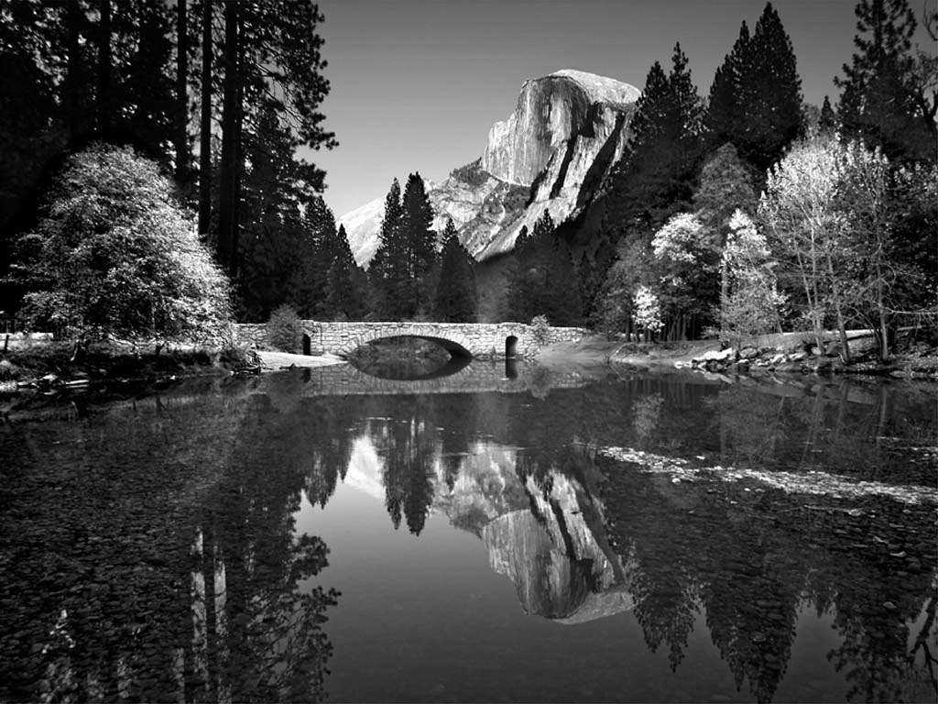

Figure 1: Example photo with high resolution. Caption created with “Reference 🡪 Insert Caption 🡪Figure” and the style changed to “Caption.”



Figure 2: Example of high resolution graphic inserted with “paste special, as enhanced metafile”

Chapter 3

# Methodology

**Note that the name of the chapter is not restricted to “Methodology”. You may use any other appropriate name. However, the materials should be similar as explained in the following.** In addition to the detailed methods, you need to describe in this section, you need to provide specific objectives and an overview of your approach if they have not already been presented in the introductory chapters. The best place to put those items can vary among theses. Sometimes the background and lit review is really necessary to justify and substantiate the specific objectives and approach and, therefore, it is best to save those details for the beginning of this chapter.

These paragraphs are in “-body text.” Other styles including captions, headers etc. can be used as presented in the previous chapter. Table 2 summarizes all of the styles that can be used with this template.

Table 2: Styles used in this template

|  |  |
| --- | --- |
| Style name | When used |
| Title  Heading 1 | Chapter #  Chapter title |
| Heading 2 | Section headers |
| Heading 3 | Sub-section headers |
| Heading4 | Sub-sub-section headers |
| -body text | All paragraphs |
| -bullets | Bullets |
| Caption | All figure captions. |
| Caption | All table captions |
| -eqn | equations |
| -reference | Reference list at end of |

Chapter 4

# Results

**Note that the name of the chapter is not restricted to “Results”. You may use any other appropriate name. However, the materials should be similar as explained in the following.** Results, findings, discussion of results OR manuscripts. It is best to also reiterate information in your literature review to help substantiate the findings of your research. **Although this template contains 5 chapters, the may have more than 5 chapters. In general, it should not be more than 7 chapters.**

This template is best used for directly typing in your content.

Chapter 5

# Evidence of Complex Engineering Problem and PO Mapping

In this chapter you should provide the evidences related to complex engineering problem and PO Mapping. This chapter is very important to show case that your project fulfills all the criteria of 12 POs.

## 5.1 Complex of Engineering Problem

Following could be the evidences that the problem that you have dealt in the project is a complex engineering problem.

1. The block diagram of the complete project showing the sub-blocks and inter dependency among the sub-blocks. If you have put the block diagram in the Chapter 3 Methodology, you may refer it here.
2. The description of the existence of multiple solution of the problem. The reasons why the particular solution is adopted for the project.
3. The optimization of the conflicting design requirements (parameters) of the project. For example, cost vs efficiency, complexity vs designed output, etc.
4. The list of innovation or new techniques adopted for the solution of the problem.

## 5.1 PO Mapping

You should provide evidence for each PO mapping in details.

|  |  |  |
| --- | --- | --- |
| PO1 | **Engineering Knowledge** | Apply the knowledge of mathematics, science, engineering fundamentals and an engineering specialization to the solution of complex engineering problems. |

You should provide a table with the list of topics of mathematics, science and engineering fundamentals and engineering specialization that are used for the solution of the complex engineering problem of your project. Following table can be adopted

|  |  |  |  |
| --- | --- | --- | --- |
| Sl. No. | Name of topics | Field: Choose one from  Science/Mathematics/Engineering Fundamental/Engineering Specialization | Description of applicable portion of your project |
| 1 | KVL | Engineering Fundamental | Voltage measured across the load and loss in the Circuit. |

Follow the above example for all the other POs.

|  |  |  |
| --- | --- | --- |
| PO2 | **Problem analysis** | Identify, formulate, research the literature and analyze complex engineering problems and reach substantiated conclusions using first principles of mathematics, the natural sciences and the engineering sciences. |
| PO3 | **Design / development of solutions** | Design solutions for complex engineering problems and design system components or processes that meet the specified needs with appropriate consideration for public health and safety as well as cultural, societal and environmental concerns. |
| PO4 | **Investigation** | Conduct investigations of complex problems, considering design of experiments, analysis and interpretation of data and synthesis of information to provide valid conclusions. |
| PO5 | **Modern tool usage** | Create, select and apply appropriate techniques, resources  and modern engineering and IT tools including prediction and modeling to complex engineering activities with an understanding of the limitations. |
| PO6 | **The engineer and society** | Apply reasoning informed by contextual knowledge to assess societal, health, safety, legal and cultural issues and the consequent responsibilities relevant to professional engineering practice. |
| PO7 | **Environment and sustainability** | Understand the impact of professional engineering solutions in societal and environmental contexts and demonstrate the knowledge of and need for sustainable development. |
| PO8 | **Ethics** | Apply ethical principles and commit to professional ethics, responsibilities and the norms of the engineering practice. |
| PO9 | **Individual work and teamwork** | Function effectively as an individual and as a member or leader of diverse teams as well as in multidisciplinary settings. |
| PO10 | **Communication** | Communicate effectively about complex engineering activities with the engineering community and with society at large. Be able to comprehend and write effective reports, design documentation, make effective presentations and give and receive clear instructions. |
| PO11 | **Project management and finance** | Demonstrate knowledge and understanding of the engineering and management principles and apply these to one’s own work as a member or a leader of a team to manage projects in multidisciplinary environments. |
| PO12 | **Life-long learning** | Recognize the need for and have the preparation and ability to engage in independent, life-long learning in the broadest context of technological change. |

Chapter 6

# Conclusion

This chapter could also be called “Conclusions and Recommendations” or “Conclusions and Implications.” In general, there should be no new information presented here. It should be a syn of information that you’ve already discussed.

# References

<Delete this part.>Includes all references: articles, media facts, books, reports, regulations, internet articles, papers that you referenced from the text. In general, in Electrical and Electronic Engineering, we follow the IEEE style in writing the references and also in citing (in the body text, where you mention a reference). Hence, the citations should be numerical and sorted according to the appearance (i.e., the first citation should be [1], next one should be [2] etc.). The hardest part in MS WORD is to maintain this numeric order, especially if your report becomes a large file. For example, you want to cite a new reference in the middle of the document, all subsequent citation should be increased by one!

Many third-party reference manager softwares are available for the automatic management of references. One example of these kinds of softwares is **Mendeley Desktop**.

Some examples are given below.

[1] D.-H. Kim, F. Merget, M. Forst, and H. Kurz, “Three-dimensional simulation model of switching dynamics in phase change random access memory cells,” *J. Appl. Phys.*, vol. 101, no. 6, p. 64512, 2007.

[2] S. Muneer, G. Bakan, A. Gokirmak, and H. Silva, “Incorporation of GTR (generation-transport-recombination) in semiconductor simulations,” *J. Appl. Phys.*, 2021.

# Appendix A

Type or paste your appendices here. Appendices are a place to organize and include all of the “extra” material that is important to your research work but that is too detailed for the main text. Examples can include specific analytical methods, computer code, spreadsheets of data, details of statistical analyses, etc. But these materials do not speak for themselves. There should be a reference to these materials from the main chapters (complete details included in Appendix A) and there should be some text at the beginning of each appendix to briefly explain what the information is and means that is included in that appendix.